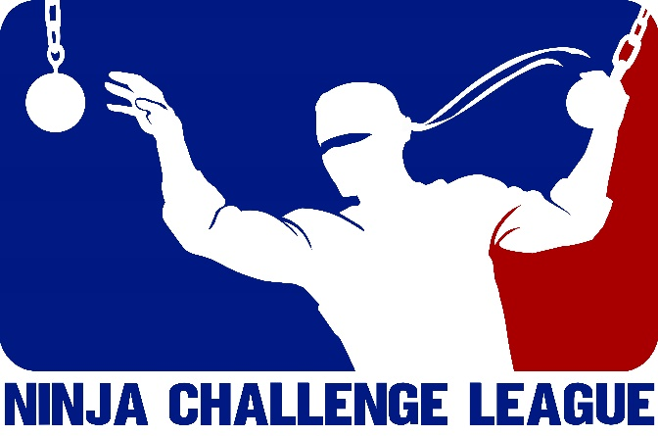

Queensland Qualifier #2 Rules

Welcome
Firstly, let me welcome you to Terrain Training on behalf of the Ninja Challenge League!
We hope you have a great time here and get the most out of your experience in this facility.
The event starts at 10am QLD time on Sunday, August 25, so please endeavour to be on time so we can run the event to time and give everyone enough time to warm-up!
These rules are designed to create a fair competition for people of all heights and body types and eliminate as much subjectivity in the judging of rules violations as possible to avoid any influence of bias.
Please read these rules carefully and in their entirety to avoid being eliminated on a rules violation on the day of competition.

General Rules:
- Competitors will only have one official attempt to run the course.
- Competitors will be randomly assigned a spot in the run order for each session on the day of competition to guarantee fairness.
- Competitors will be offered a spray bottle and towel to clean their feet immediately before their run.
- Competitors must remove all chalk from their hands before their run begins.
- Runs always begin with the judge’s whistle.
- All competitors must wear enclosed shoes.
- Touching the floor while attempting an obstacle results in elimination.
- Competitors must finish each obstacle with control or spend at least two seconds on the platform before moving on to the next obstacle. What constitutes an uncontrolled landing is determined at the judge’s discretion.
- Competitors may only rest for 30 seconds between obstacles without being eliminated, they will be given a 15 second warning, a 10 second warning and a 5-second countdown. The rest period will start as soon as a competitor completes an obstacle.
- Chalk and other performance aids will be provided where they are deemed beneficial by the Commissioner.
- The judge’s decision is always final, but if a competitor is disqualified for violating a rule, they may request a video review in person, immediately following the conclusion of their run, but must accept any ruling made by the designated NCL judge.
- If an NCL judge thinks a violation has occurred but wants to check the video review before making a final ruling, he or she will flag this during the run, but the competitor will be allowed to continue and the incident will be reviewed afterwards. Any change in ruling after this video review will be final.
- Rankings will be determined by furthest the fastest. The furthest the fastest will be determined by the last obstacle successfully completed or part of obstacle reached according to pre-determined checkpoints.
- The number of positions available in the NCL Finals at this event will depend on the number of competitors of each sex at this event, as follows:
  - 1 to 5 men/women: top competitor of that sex qualify for the NCL Finals.
  - 6-10 men/women: top three competitors of that sex qualify for the NCL Finals.
  - 11+ men/women: top five competitors of that sex qualify for the NCL Finals.
- Competitors who qualify for the NCL Finals will have 30 days from the publication of results of that qualifier to accept their invitation and purchase a ticket to the NCL Finals 2019. Competitors who decline the invitation, fail to respond or purchase their ticket within this period will forfeit their invitation to the next eligible competitor from that qualifier.
- If a competitor who has already qualified performs well enough to earn a qualifying position in a subsequent event, the qualifying spot is given to the next eligible competitor from the subsequent event.
- Points will be awarded after each qualifier based on the competitor’s position in the standings for that event, these will have no impact on a competitor’s eligibility for the NCL Finals but will affect seeding at the event.
- For a full list of general rules governing the NCL 2019 Qualifiers, visit the Rules & Format section of the Ninja Challenge League website.

Obstacle Rules:

1. First Obstacle – Steps to Spider
- Start from black jigsaw mats to steps. Use feet only to run along all steps, then jump from the last step to catch the double rings, then lache to the wooden horizontal pole, use hands and feet to traverse the spider walk, then use hands to swing from the next set of double rings (single ring is permitted) to the hanging V, then another ring and use the rope with both hands to dismount onto the mat directly beneath the rope.
- The scoring checkpoints for this obstacle are as follows:
  - Step 1-5
  - Step Rings
  - Spider Walk
  - Spider Rings
  - Hanging V
  - V Rings
  - Steps Rope
  - Steps Dismount
- A dismount is assessed if the competitor makes partial contact with the correct mat using the rope but then fails to properly dismount

2. Second Obstacle – Slackline to Pegboard
- Step from the blue padding to walk along the blue slackline with feet only to reach the blue padding to rings, swing along the rings (do not have to use all rings) to reach the balance beam and walk along it using feet (the last ring may be used while on the balance beam) only then step across to the pegboard step and use hands only to use the pegs (must take all body weight in your hands first before starting) to get both pegs into the final two holes before dismounting onto the mat below.
- The scoring checkpoints for this obstacle are as follows:
  - Slackline
  - Slack Ring 1-4
  - Beam
  - Peg Hole 1-15

3. Third Obstacle – Log Thread
- Chalk and a hand towel for sweat will be provided at the start of this obstacle – it is up to the competitor to use one or both.
- Jump from the black jigsaw mats to the first horizontal bar, then use hands/arms/legs to traverse the log, then use the remaining three horizontal bars (hands only) to reach the black jigsaw mats.
- The scoring checkpoints for this obstacle are as follows:
  - Log Bar 1
  - Log Half 1-2
  - Log Bar 2-4

4. Fourth Obstacle – Tyres to UFOs
- Starting on the black jigsaw mat, jump to the first tyre (the tyre may be out of reach for some competitors and a stick will be provided to move the first tyre), contacting whatever sections are necessary and transition between the remaining three before using hands only to traverse the two UFOs to reach the ring, then use the remaining rings to reach the last ring (both hands must be on the last ring) before dismounting to the mat below.
- The scoring checkpoints for this obstacle are as follows:
  - Tyre 1-4
  - UFO 1-2
  - UFO Ring 1-3

5. Fifth Obstacle – Bar Toss to Hooks
- Use the first ring to leave the ground and use the remaining rings to reach the fixed horizontal bar before transferring to the sliding bar and slide/jump it along the rails/over all the pegs before transitioning to the axes, sliding them along to reach the mobile rings and manoeuvre them until they are in the last hooks (every hook must be used) before transitioning to the handlebar (there must be a hand on either side of the handle bars) and dismounting to the mat below.
- The scoring checkpoints for this obstacle are as follows:
  - Bar Toss Ring 1-3
  - Fixed Bar
  - Bar Toss Bar
  - Bar Pegs 1-4’] or both.
- Use the rope to reach the first ring, then swing on rings (rings can be skipped) to reach the black jigsaw mat. Both hands must be on the final ring before dismounting.
- The scoring checkpoints for this obstacle are as follows:
  - Ring Rope
  - Ring 1-11

8. Eighth Obstacle – Salmon Ladder
- Chalk and a hand towel for sweat will be provided at the start of this obstacle – it is up to the competitor to use either or both.
- Take weight on the salmon ladder bar while it is on the starting rungs, then use as many moves as needed to get both sides of the bar to the top set of rungs, then dismount to the blue mats.
- Scoring checkpoints are as follows:
  - Salmon Start
  - Salmon Rungs 1-3
- If only one side of the bar reaches a set of rungs and the competitor falls, the competitor is considered to have reached the last set of rungs that both sides of the bar successfully reached.
If you have any questions regarding any of the rules or anything is unclear, please email the Commissioner at commissioner@ninjachallengeleague.com.
A video demonstrating the correct completion of the course is available on our YouTube Channel.

